Install VirtualBox 6 on Debian 11

In this guide, we will cover the installation of VirtualBox 6 on Debian 11 / Debian 10 Linux system. VirtualBox 6 is available for Windows and Linux users with plenty of new features. For those new to VirtualBox, it is a free to use and feature-rich Virtualization platform for x86 and AMD64/Intel64 systems.
For other platforms, refer to how to install VirtualBox on Ubuntu / CentOS / Fedora. Follow these few steps to install and enjoy VirtualBox on Debian 11|10 Desktop Linux distribution.

Step 1: Update your system
The first step is to ensure your system is updated.
sudo apt update && sudo apt -y upgrade
Reboot since there could be kernel updates.
[ -f /var/run/reboot-required ] && sudo reboot -f

Step 2: Import VirtualBox apt repository
Once the system is updated, import repository GPG key used for signing packages.
sudo apt -y install curl wget gnupg2 lsb-release
curl -fsSL https://www.virtualbox.org/download/oracle_vbox_2016.asc|sudo gpg --dearmor -o /etc/apt/trusted.gpg.d/oracle_vbox_2016.gpg
curl -fsSL https://www.virtualbox.org/download/oracle_vbox.asc|sudo gpg --dearmor -o /etc/apt/trusted.gpg.d/oracle_vbox.gpg

Step 3: Add the VirtualBox Repository
After the importation of GPG key, add VirtualBox repository to your system using the following commands.
echo "deb [arch=amd64] http://download.virtualbox.org/virtualbox/debian $(lsb_release -cs) contrib" | sudo tee /etc/apt/sources.list.d/virtualbox.list

Step 4: Install VirtualBox & Extension pack
The final step is the actual installation of VirtualBox and extension pack which extends VirtualBox features.
sudo apt update
sudo apt install linux-headers-$(uname -r) dkms
sudo apt install virtualbox-6.1
Download Extension Pack:
cd ~/
wget https://download.virtualbox.org/virtualbox/6.1.34/Oracle_VM_VirtualBox_Extension_Pack-6.1.34.vbox-extpack
You can also download it manually https://www.virtualbox.org/wiki/Downloads
Once the file is downloaded, install the extension pack by clicking on the Downloaded file.
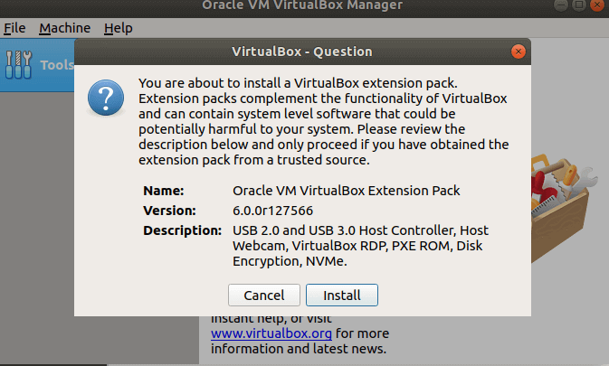
Click install and wait for the installation to complete.
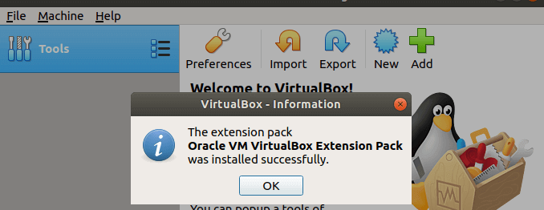

https://computingforgeeks.com/install-virtualbox-ubuntu-debian/

